SIMATS ENGINEERING
ASSESSMENT TOOL 3

COURSE NAME: Ethical Hacking
COURSE CODE: ITA1409

COURSE OUTCOME COVERED

CO2: Execute footprinting in social engineering such as DNS analysis, competitive intelligence gathering, and attack simulations to collect relevant information for identifying potential security risks.. (BT4)
Assessment Tool Weightage: 30%

Code of Conduct:

I Palle Amrutha (192372359) certify that this submission is my original work and that I have adhered to the guidelines specified for this assessment.
I understand that any violation of academic integrity rules will result in disciplinary action.

Signature of the student: P.Amrutha

Scenario-Based Assessment

Topic 1: Footprinting Tools – Conducting Competitive Intelligence
A cybersecurity consultant has been assigned to perform a passive security assessment for a company named ABC Technologies. The consultant must collect publicly available information without directly interacting with the company’s servers.
Task: Apply suitable footprinting tools to identify the company’s:

- domain registration details,

- employee email addresses,

- technology stack,

- and publicly exposed subdomains.

Explain how each selected tool helps in conducting competitive intelligence.
1. Aim
To demonstrate passive footprinting techniques for collecting publicly available domain, DNS, email, technology-stack, and subdomain information, using command-line and public lookup tools.
2. Scope and Important Limitation
The assessment question refers to ABC Technologies but does not provide its actual website or domain name. Therefore, example.com was used only as a sample domain to demonstrate domain-registration lookup and DNS commands. The observations below describe example.com only; they must not be interpreted as verified findings about ABC Technologies. No direct access to ABC Technologies systems was attempted.
3. Tools Used
Tool | Purpose | Observation / limitation
ICANN Lookup (RDAP) | View public domain-registration data such as registrar, dates, status and nameservers. | Sample-domain registration details were viewed in the public lookup.
dig | Query DNS record types such as A, NS and MX. | TCP DNS queries for example.com returned NS and A records; its MX response was a Null MX.
theHarvester | Collect publicly indexed email addresses, hosts and related footprinting information from supported sources. | Queries using crt.sh and DuckDuckGo returned no email addresses or hosts in this run.
4. Procedure and Commands
Step 1 – Domain registration lookup
Opened ICANN Lookup and searched for example.com. Recorded the registrar, registration/expiration dates, domain status and authoritative nameservers. This is a public lookup and does not require logging into the domain.
Step 2 – DNS enumeration in Kali Linux
dig +tcp @8.8.8.8 example.com NS
dig +tcp @8.8.8.8 example.com A
dig +tcp @8.8.8.8 example.com MX
Step 3 – Passive footprinting with theHarvester
theHarvester -d example.com -b crtsh -l 50
theHarvester -d example.com -b duckduckgo -l 50
5. Results and Observations
ICANN Lookup showed example.com as the sample domain, with registrar listed as RESERVED-Internet Assigned Numbers Authority (IANA ID 376), creation date 14 August 1995, expiry date 13 August 2027, and nameservers ELLIOTT.NS.CLOUDFLARE.COM and HERA.NS.CLOUDFLARE.COM. These values are recorded from the user-provided lookup output and relate only to example.com.
The DNS NS query returned the authoritative nameservers elliott.ns.cloudflare.com and hera.ns.cloudflare.com.
The DNS A query returned IPv4 addresses 104.20.23.154 and 172.66.147.243 in the observed response.
The DNS MX query returned “MX 0 .”, which is a Null MX record indicating that example.com does not accept email.
theHarvester runs using crt.sh and DuckDuckGo reported no email addresses, people, or hosts in those results. A zero-result search does not prove that no public email addresses or subdomains exist.
6. Required Intelligence Categories
Information category | Status | Explanation
Domain registration | Demonstrated for sample domain | ICANN Lookup provides public registration and nameserver information.
DNS records | Demonstrated for sample domain | A and NS records were retrieved; the MX response showed Null MX.
Employee email addresses | Not verified | No addresses were returned by the tested theHarvester sources.
Technology stack | Not assessed | The actual ABC Technologies website/domain was not provided, so no company-specific stack can be verified.
Public subdomains | Not verified for ABC Technologies | The tested theHarvester sources returned zero hosts; this is inconclusive and is not proof that no subdomains exist.
7. Security Relevance
Passive footprinting can help an authorized security team understand its public exposure. Registration and nameserver details can support asset inventory; DNS records can reveal public-facing infrastructure; publicly indexed email addresses can inform awareness planning; and technology identification can help prioritize patch management. These observations should be validated and used only within an authorized assessment.
8. Conclusion
This exercise demonstrated ICANN Lookup, dig, and theHarvester for passive-footprinting tasks. DNS and registration observations were collected for example.com as a sample. Because the assessment did not provide ABC Technologies’ actual domain, its employee emails, technology stack, and public subdomains could not be verified. The sample results should not be reported as facts about ABC Technologies.
9. Screenshot Placement
Figure 1: ICANN Lookup result for example.com (registration details and nameservers).
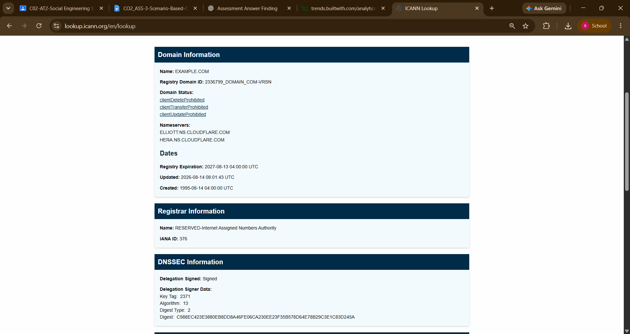

Figure 2: Terminal output of dig +tcp @8.8.8.8 example.com NS.
Figure 3: Terminal output of dig +tcp @8.8.8.8 example.com A.
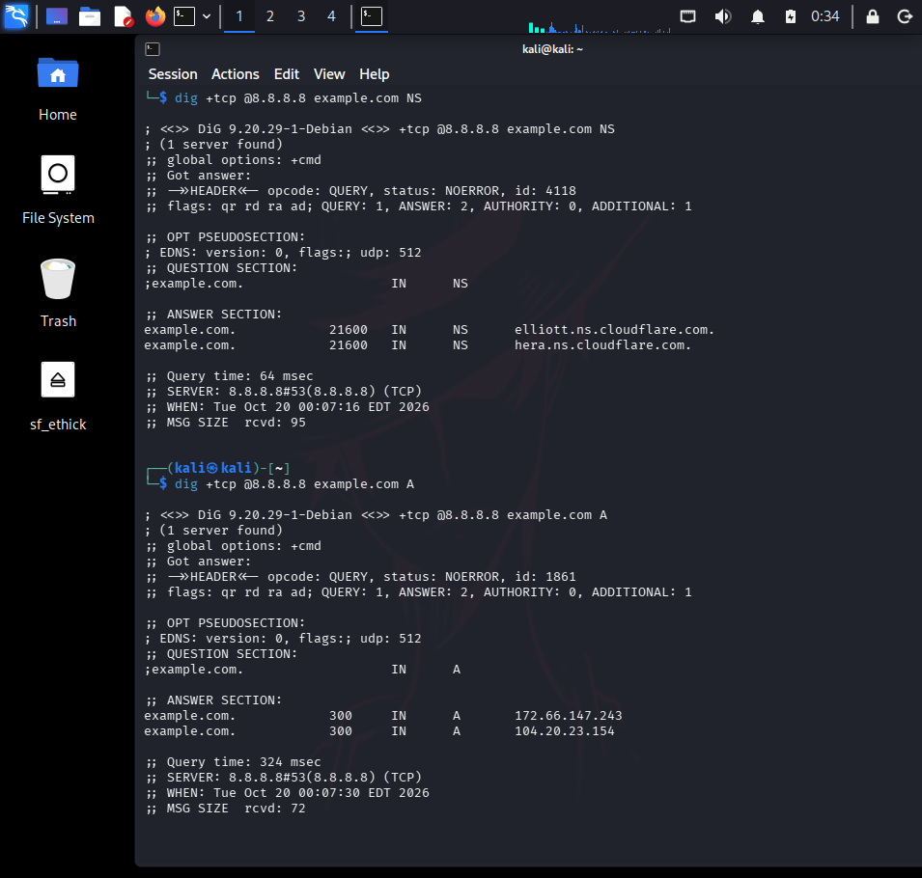
Figure 4: Terminal output of theHarvester runs showing the returned results.
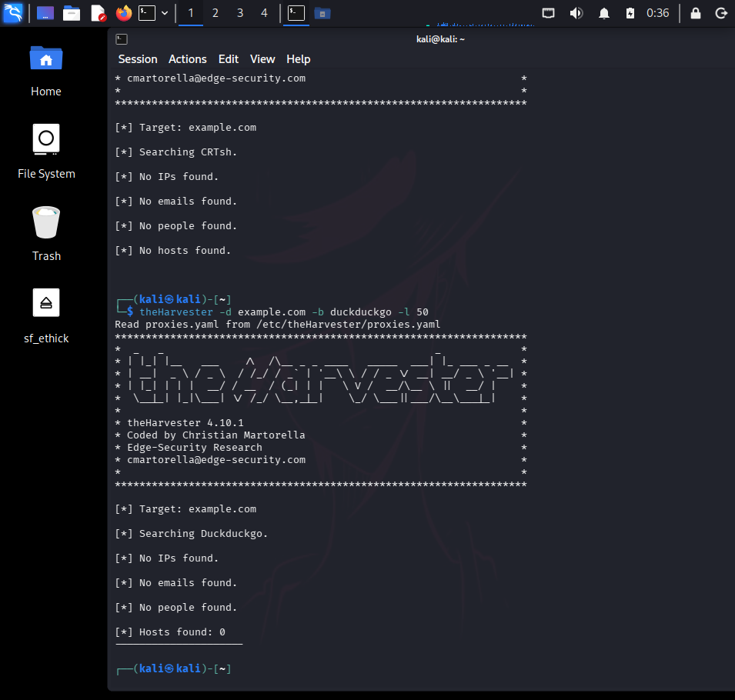
Insert the corresponding screenshots below each figure caption before submitting. Ensure the command and its output are visible. Label every screenshot as a sample-domain demonstration.

Topic 2: DNS Zone Transfers
During an authorized penetration test, a security analyst suspects that the target organization’s DNS server is misconfigured and may allow unauthorized DNS zone transfers.
Task: Apply the appropriate DNS command or tool to verify whether zone transfers are permitted. If the transfer succeeds, explain how the retrieved DNS records can be used to identify internal hosts, mail servers, and subdomains during reconnaissance.
1. Aim
To demonstrate a DNS zone-transfer (AXFR) test in an isolated, locally controlled lab and explain the security implications of DNS zone-transfer exposure.
2. Lab Environment
Operating system: Kali Linux
Container platform: Docker
DNS server: BIND9 (internetsystemsconsortium/bind9:9.18)
Docker network: dns-lab (subnet 172.20.0.0/24)
DNS zone: lab.test
DNS service mapping: 127.0.0.1:5353 to container port 53 (TCP/UDP)
The lab used fictional hostnames and documentation-only IP addresses (192.0.2.0/24). Only the locally configured DNS server was tested; no third-party or ABC Technologies server was queried.
3. Tools Used
Tool / command | Purpose | Observed result
Docker | Runs an isolated BIND9 DNS server and lab network. | Container dns-server was shown as Up.
dig SOA | Checks the zone's Start of Authority record. | Returned status NOERROR and SOA data for lab.test.
dig A | Queries an IPv4 address record. | www.lab.test returned 192.0.2.20.
dig AXFR | Requests a full DNS zone transfer over TCP. | Transfer succeeded and reported 8 records.
4. Procedure and Commands
Create a Docker network for the local lab: sudo docker network create --subnet 172.20.0.0/24 dns-lab
Download the BIND9 image: sudo docker pull internetsystemsconsortium/bind9:9.18
Start the DNS container: sudo docker run -d --name dns-server --network dns-lab --ip 172.20.0.10 -p 127.0.0.1:5353:53/udp -p 127.0.0.1:5353:53/tcp -v ~/dns-lab/named.conf:/etc/bind/named.conf:ro -v ~/dns-lab/db.lab.test:/etc/bind/db.lab.test:ro internetsystemsconsortium/bind9:9.18
Check zone SOA: dig @127.0.0.1 -p 5353 lab.test SOA
Check www A record: dig @127.0.0.1 -p 5353 www.lab.test A
Test zone transfer: dig @127.0.0.1 -p 5353 lab.test AXFR
5. Results and Observations
SOA query: status was NOERROR. The answer included ns1.lab.test as the primary name server and admin.lab.test as the responsible mailbox field.
A-record query: www.lab.test returned 192.0.2.20.
AXFR query: the transfer completed successfully. The output listed SOA, MX, NS, and A records for dev.lab.test, mail.lab.test, ns1.lab.test, and www.lab.test.
The command reported “XFR size: 8 records (messages 1, bytes 254)”. This confirms that the configured lab server allowed the transfer.
6. Security Analysis
DNS zone transfers are normally used to replicate DNS data between authorized DNS servers. If a DNS server permits unrestricted AXFR requests, an unauthorized requester may retrieve the zone's records. Depending on the zone contents, these records can help build an inventory of hostnames, mail servers, development systems, and other DNS entries. A successful AXFR test in this local lab does not prove that any real organization has the same configuration or is vulnerable.
7. Recommendations
Restrict zone transfers to explicitly authorized secondary DNS servers.
Use access-control lists and, where appropriate, TSIG authentication for zone transfers.
Review DNS configuration and monitor logs for unexpected AXFR requests.
Avoid exposing unnecessary internal hostnames in public DNS zones.
Repeat security testing only against systems for which written authorization has been granted.
8. Conclusion
The DNS zone-transfer test was successfully demonstrated in a locally controlled BIND9 lab. The AXFR response returned eight records, showing how unrestricted transfers can disclose zone information. The exercise met the practical objective of demonstrating AXFR and identifying appropriate mitigations
9. Screenshot Placement
Figure 1: Docker container status showing dns-server as Up.
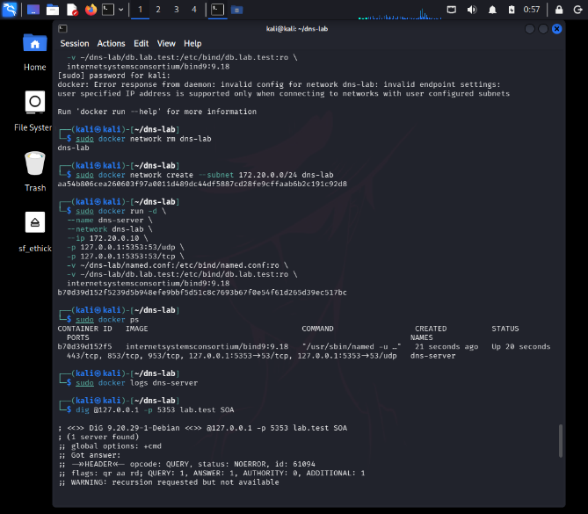
Figure 2: Successful SOA query for lab.test.
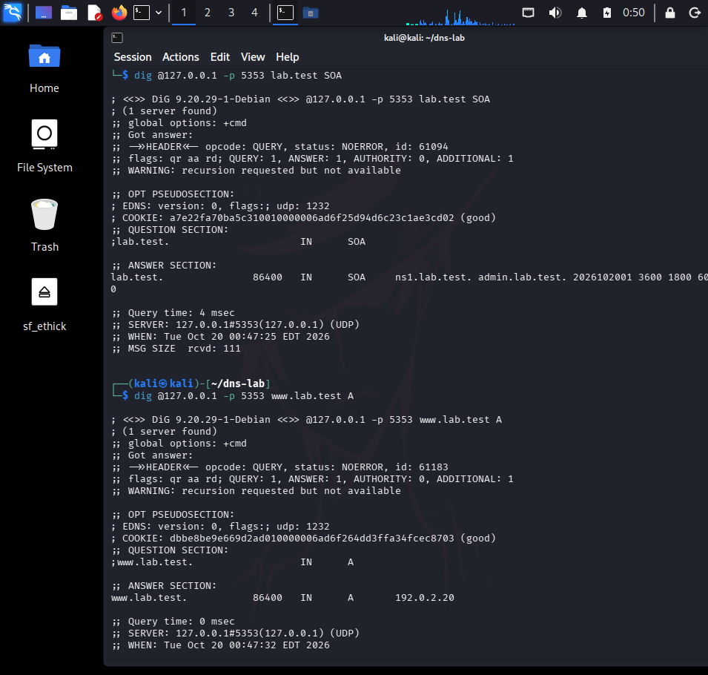
Figure 3: Successful A-record query for www.lab.test.
Figure 4: Successful AXFR output showing the eight sample zone records.
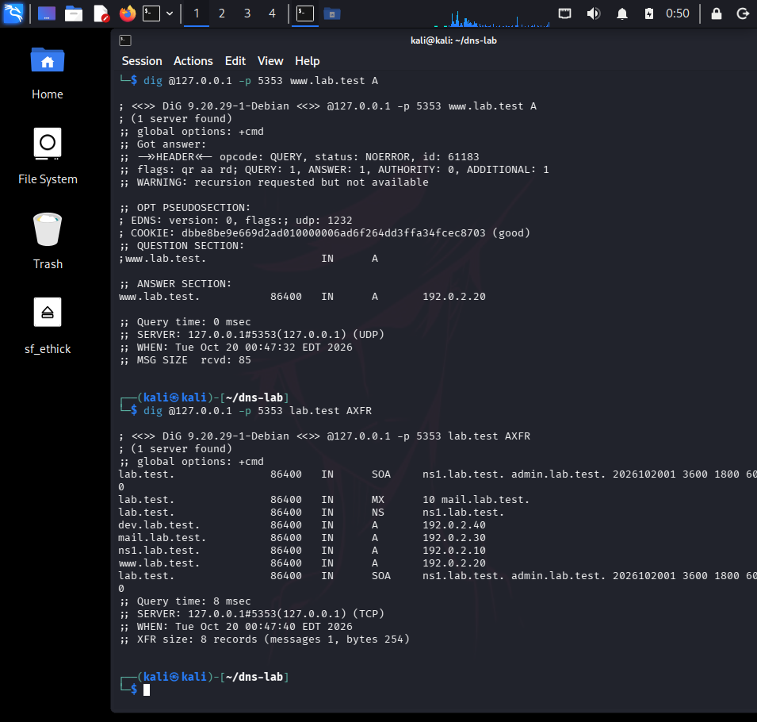
Insert the corresponding terminal screenshots beneath the figure captions. Keep the command and output visible. Label the results as a local lab demonstration.
Topic 3: Introduction to Social Engineering – Social Engineering Attacks and Countermeasures
Employees of an organization receive an email claiming to be from the IT department, asking them to verify their login credentials through a provided link because of an urgent security update.
Task: Identify the type of social engineering attack and apply suitable countermeasures that employees should follow before responding to the email. Explain how these actions help prevent credential theft.
1. Aim
To identify a credential-harvesting phishing attempt and describe suitable preventive, detective, and responsive security measures.
2. Scenario
Employees receive an email claiming that an urgent security update is required and asking them to verify their login credentials. The message may use urgency and a link to a fake login page to persuade recipients to disclose their usernames and passwords.
3. Identify the Attack
This is a phishing attack, specifically credential-harvesting phishing. The attacker impersonates a trusted organization or IT/security team and uses an urgent request to trick employees into entering credentials on a fraudulent website or replying with sensitive information.
Warning signs include:
Urgent or threatening wording that pressures the recipient to act immediately.
A request to verify, share, or re-enter a password through an email link.
A sender address or domain that does not match the legitimate organization.
A link whose displayed text differs from its actual destination.
Unexpected attachments, spelling errors, or unusual requests that bypass normal IT procedures.
4. Possible Impact
Stolen credentials may allow unauthorized access to employee accounts.
Attackers may access company email, files, or internal applications.
Compromised accounts may be used for further phishing, business email compromise, or malware delivery.
Sensitive information may be exposed, altered, or deleted.
5. Preventive Countermeasures
Security awareness training: teach employees to recognize urgency, impersonation, suspicious links, and credential requests.
Email security controls: deploy spam filtering, anti-phishing detection, domain authentication checks, and malicious-link/attachment scanning.
Multi-factor authentication (MFA): require MFA, preferably phishing-resistant methods such as passkeys or security keys.
Password policy: use unique passwords and a password manager; never request passwords by email.
Safe verification: employees should contact the IT/security team through a known, official channel rather than using the email's link or contact details.
Web protection: block known phishing domains and use browser/DNS filtering where appropriate.
Least privilege: limit account permissions so a compromised account causes less damage.
6. Response if an Employee Clicked or Entered Credentials
Report the email immediately to the IT/security team and preserve the message for investigation.
If credentials were entered, reset the password from the official site using a trusted device; change reused passwords on other services.
Revoke active sessions and refresh tokens where supported, and review MFA methods.
Check sign-in logs for suspicious locations, devices, or activity; investigate any affected mailbox rules or forwarding settings.
Block the phishing URL/domain and remove similar messages from other mailboxes when possible.
If a file was downloaded or executed, isolate the affected device and run the organization's endpoint-response procedure.
Document the incident, affected accounts, timeline, containment steps, and lessons learned.
7. Example Employee Reporting Procedure
Do not click the link or reply with credentials. Use the organization's approved 'Report Phishing' function or forward the message to its designated security mailbox according to company policy. Verify urgent IT requests using a known phone number, internal help desk, or official portal.
8. Conclusion
The email described in the scenario is a credential-harvesting phishing attempt. Urgency and a request to verify login credentials are key warning signs. Awareness training, email filtering, phishing-resistant MFA, safe request verification, and a clear incident-response process reduce the likelihood and impact of successful phishing.
9. Screenshot / Evidence (if required)
This question is scenario-based and can be answered in a written report without sending a phishing email or collecting real credentials. If the assessment requires evidence, use a clearly labelled mock email screenshot with fake names and a non-functional example link; do not send it to real employees or collect passwords.
